EC5070: Database Systems Lab 04

NAME

2022/E/XXX

06.06.2025

**Attach the below screenshots for following scenarios.**

Q1. Database with your registration number and lab number.

Q2. Tables with the name sample population and population.

Q3. Importing .csv files using import data wizard.

Q4. Importing .csv files using queries

Q5. Explanation of your observation for question 3,4.

Q6. Attach the screen shots for each queries given in question 6.

Q7. Screenshot for create the primary key for two tables and the listed queries in question 4.

Q8. Screenshot for create the secondary index for these two tables and do the queries again (in question 4) and the time duration.

Q9. Explanation for question 4,5,6.

Here some sample code for your reference:

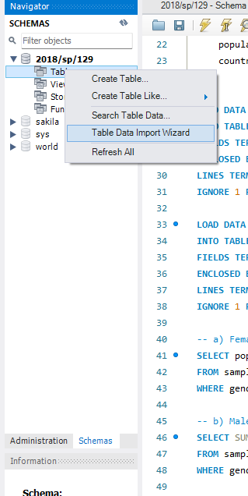Q3.

Q4.

